Day 1 - individual component exercises
09:45-10:00 setup verification: confirm route, assigned access, files and previously installed tools; no classroom installs. This is inside the existing opening block. See 02_Pre_Course_Setup_And_Prerequisites_Guide.docx in the attendee-pack root.

Confirmed delivery window - 09:45-17:30
The opening includes a 15-minute guided portal walkthrough before individual practice. SQL and Blob include short paired cost decisions: state the workload assumption, cost driver, safe recommendation and risk. Day 2 monitoring and cost guides are optional references, not primary agenda blocks.
Start | Finish | Block
09:45 | 11:05 | Welcome, introductions, foundations and orientation
11:05 | 12:20 | SQL including cost decision
12:20 | 12:35 | Break
12:35 | 13:40 | Blob including cost decision
13:40 | 14:25 | Lunch
14:25 | 15:40 | Function
15:40 | 15:55 | Break
15:55 | 16:50 | Logs/KQL
16:50 | 17:30 | Troubleshooting, knowledge check, cost recap and cleanup

Follow this order
1. Orientation: Basic_Lab_VS_Code_Azure_Function_And_Dummy_Tracker.docx, orientation-only route, Parts 1-2. Do not require Function tools for discovery.
2. SQL: Basic_Lab_01_Azure_SQL_Portal_And_VS_Code.docx. Prepare access, create/read rows, add Notes, update and verify in portal and MSSQL.
3. Blob: Basic_Lab_02_Blob_Storage_Portal_And_VS_Code.docx. Private container, network/IAM, portal and terminal transfers, then hash comparison.
4. Function: return to the Function guide, Parts 3-5 and relevant Part 8 evidence/cleanup. Do not deploy to another attendee's host.
5. Logs/KQL: Basic_Lab_03_Log_Analytics_Portal_And_VS_Code.docx. Same synthetic query in portal and terminal; this does not prove telemetry ingestion.
6. Optional local UI: Function guide Parts 6-8, only if assigned.

Where are the project files?
From the attendee-pack root open Labs\PortalAndVsCodeBasics for SQL/Blob/Logs; open Labs\VsCodePublishBasics\HelloAzureFunction for the Function.
Optional - Portal Resource Creation contains additional creation exercises, not a requirement to create duplicate Azure resources. Owner approval is needed.
Record each result as Passed, Blocked or Not run. Keep passwords, tokens and real document content out of screenshots.

Day 1 troubleshooting and evidence support
V3 student support. Use this illustrated support section alongside the numbered lab;

1. Follow the course route; these are separate exercises
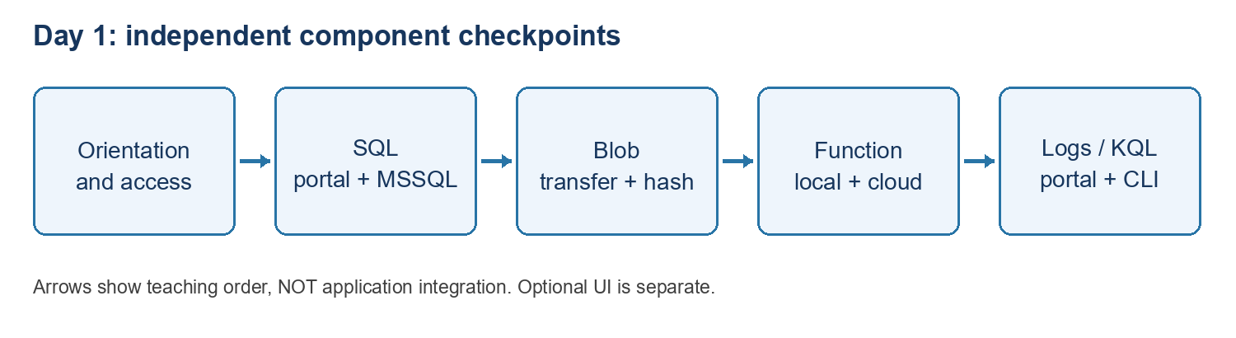
Diagram: day1 route
Use fictional training data only. Orientation, SQL, Blob Storage, the HTTP Function and Logs/KQL are independent checkpoints. They do not form a connected document-processing application. The local dummy UI is optional.

Open the supplied lab folder
Use the supplied attendee-pack location. SQL, Blob and Logs use Labs\PortalAndVsCodeBasics; the Function uses Labs\VsCodePublishBasics\HelloAzureFunction. Quote paths containing spaces. Set-Location changes the terminal folder only; File > Open Folder changes the VS Code workspace.
Set-Location "C:\YOUR-ATTENDEE-PACK\Labs\PortalAndVsCodeBasics"
Get-Location
Test-Path .\Samples\Logs\01-fictional-status.kql
Replace the placeholder with your extracted attendee-pack path before running the command. Test-Path should be True. Open the required project folder in VS Code; do not repeat cloud changes just because a local workspace or terminal was reopened.

Sign-in and permissions are separate
Portal sign-in, VS Code Azure Resources, MSSQL and Azure CLI have separate sign-in contexts. Confirm the approved tenant, subscription and target. Azure Reader shows resources but does not automatically grant SQL queries, Blob transfers, Function key access or publishing rights.
az account show --query "{name:name,id:id,tenant:tenantId}" -o table
If CLI sign-in is missing, use az login with your approved account. Do not paste tokens, passwords, keys, connection strings or key-bearing URLs into chat or evidence. Never broaden network or role permissions to work around an unexplained error.

6. Finish safely and record your own evidence
Record Passed, Blocked or Not run separately for each item: resource discovery; SQL portal connect/create/read; SQL MSSQL read/alter/update; portal recheck; Blob transfer and hashes in both directions; local Function build/invocation; publishing approval/result or test-only; cloud keyed response and keyless rejection; portal/terminal KQL match.
Capture the target, time, command and expected/actual non-secret output. An instructor screenshot is an example, not your pass. SQL rows and schema do not prove which tool wrote them. A green deployment is not an invocation. A reported key rotation is not independent proof the exposed key was invalidated.
Record the results from your own assigned session. The guide defines expected outcomes; it does not claim that a live cloud walkthrough was run or passed. Keep any blocked checks and approved exceptions explicit.
Stop your own local Function with Ctrl+C. Close Azurite only if you started it and no other work needs it. Disconnect the SQL client and sign out on shared machines. Local shutdown does not stop cloud billing. Do not delete shared resources or restore network/role changes without owner approval; temporary permission cleanup requires checking dependencies and verifying the narrower approved access first.
Day 1 is ready for sign-off only when each required checkpoint has evidence or an approved exception. Record access limitations and open actions with the instructor. Do not infer completion from an example, screenshot or draft.

